# Design

## Introduction

This chapter describes the design of the application. The purpose of the design phase of the project is to allow for developers to arrive at a design for the application so that the application meets the requirements for the application as set out in the Requirements chapter.

The application for this project is to create and explore the area of recommender systems within the music industry. The project, titled ‘Festivly’ will be a content-based recommender system that will recommend concerts/festivals and artists to users based on their preferred types of music. The user will be allowed to save these recommendations to remind them for future use.

## Program Design

The program design refers to the design required to make the task of programming and coding of the application more straightforward.

### Technologies

The technologies being used to create this application are:

* React
* Material UI
* Python
* Github
* Figma
* Miro

These technologies were chosen because as things stand with my level of knowledge in regard to the first 3 technologies, I know little about them. They were introduced to the group at the start of 4th year and as a result something I want to further increase my level of understanding of. We used React for our Advanced JavaScript module and Python in our Artificial Intelligence module. Github is also being used as there needs to be a way of keeping a log of updates to the project as well as being able to share this project with my supervisors. Finally, Figma and Miro are technologies being used to wireframe and design the look of the web application and act as a drawing board for the project.

These technologies complement each other well so there should be no compatibility issues between them.

### Structure of Laravel/Unity/Android (2 pages)

Describe the structure of whichever technology you are using, for instance the various folders inside of Laravel, the use of routes controllers and views. Include diagrams.

### Design Patterns

The Design Pattern for a React Project follows the Higher Order Component. A higher-order component (HOC) is an advanced technique in React for reusing component logic. HOCs are not part of the React API, per se. They are a pattern that emerges from React's compositional nature. Concretely, a higher-order component is a function that takes a component and returns a new component.

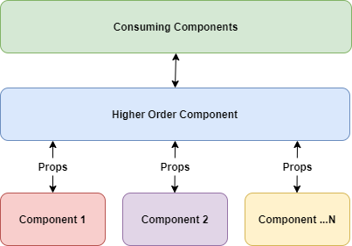

### Process design

There are a number of techniques which can be used to aid the coding of an application. The following diagramming techniques are some of the ones which could be useful. Discuss with your supervisor what is appropriate for your project.

* Class diagrams
* Sequence diagrams
* Flow charts
* Pseudocode

## User interface design

### Wireframes

These images contain the landing page the user sees before they register and the homepage itself when they login. As you can see the design is very clean and there is little clutter while keeping the user informed on the main areas of the site, so they are not confused.

### User Flow Diagram

This shows how the user will navigate from one page to another page within the application.

### Style guide

Figure 1: Colour Palette

Figure 2: Colour Style components in Figma

Figure 2 shows the colour scheme that will be used in the application. Purple will be the primary colour used and the greys compliment this colour well. There are several shades of grey that will be used throughout the website. A dark grey will be used instead of black, as full black can be overpowering. These colours have been extracted to styles in Figma, making it easier to re-use the colours throughout the wireframes, resulting in a consistent design pattern.

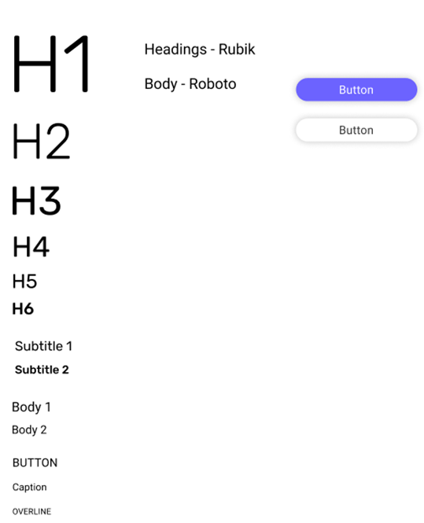

Figure 3: Font scale and components

This is the type-scale used in the application. This was created using material.io’s type scale generator. The Rubik font family will be used for headings and Roboto for the body text. These are both sans-serif fonts that complement each other. The button components are included in this document also.

## Conclusion

In conclusion this is the direction the team and I will be heading towards for the design of the application. The project area focuses on music and content-based recommenders. The team has taken inspiration from good design features from popular websites in this area. A design system has been followed and as a result a consistent design for the user interface has been created. Different iterations of sketches have made it clear what is important to the user and how the website should be laid out. In terms of program design, this has been carried out successfully since the team spent time learning and get comfortable using the technologies required to build the application. The process design and UI design were created prior to the coding stage, making it easier for the team to start building the application without encountering problems with things such as database relationships.